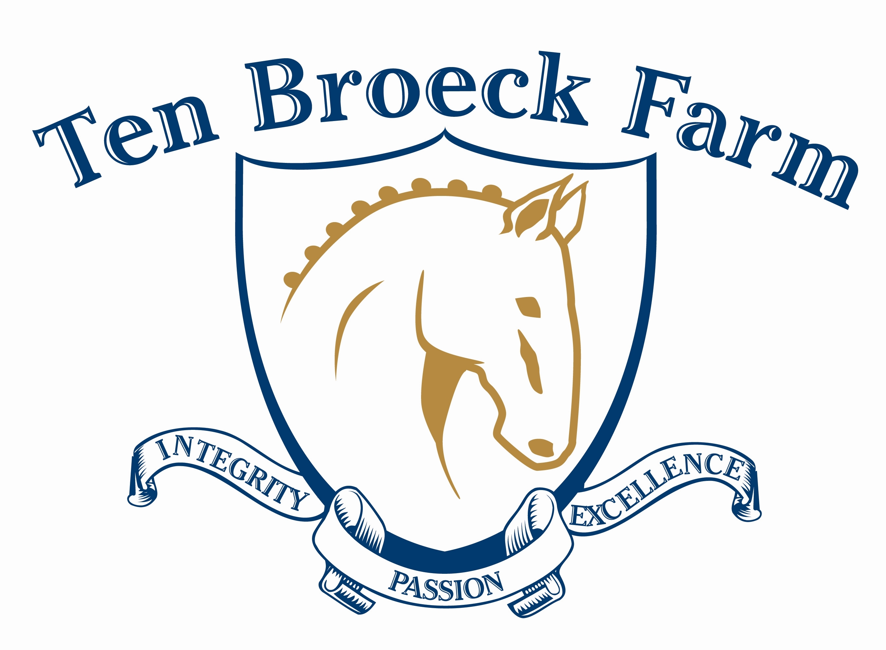

Ten Broeck Farm Presents...
Prepare Your Horse for Breed Shows and Inspections
Handling Clinics with Phil Silva
Saturday, April 27 ● Saturday, May 25
~all levels welcome~

REGISTRATION (page 1 of 2) ONE FORM PER DATE □ April 27 □ May 25
2013 HANDLING CLINICS
NAME OF PARTICIPANT

ADDRESS

CITY |  |  |  | STATE |  | ZIP
PHONE/CELL |  |  |  | EMAIL
AGE | □ 4H member  □ D4K participant |  |  | PARENT (if under 18)
HORSE NAME |  |  |  |  |  |  |  | AGE | SEX
BREED |  |  | If you are not bringing your own horse, TBF will provide a horse for your session. Please check here so we can plan accordingly.  □ I will not bring a horse
MUST HAVE CURRENT COGGINS
SEE ENTRY CHECK LIST ON PAGE 2.
EMERGENCY CONTACT |  | PHONE |  |  |  |  | CELL
NAME OF PARTICIPANT

ADDRESS

CITY |  |  |  | STATE |  | ZIP
PHONE/CELL |  |  |  | EMAIL
AGE | □ 4H member  □ D4K participant |  |  | PARENT (if under 18)
HORSE NAME |  |  |  |  |  |  |  | AGE | SEX
BREED |  |  | If you are not bringing your own horse, TBF will provide a horse for your session. Please check here so we can plan accordingly.  □ I will not bring a horse
EMERGENCY CONTACT |  | PHONE |  |  |  |  | CELL
Total number of participants:  ____________  D4K and 4H participants save $10! |  |  |  |  | Fees |  |  |  |  | Total $
 |  |  |  |  | $55.00 (lunch included)  $45.00 per person |  |  |  |  | $
Auditing: Non-participants/parents/spectators welcome |  |  |  |  | Phone |  |  |  |  | Total $
Name:
□ Youth □ Adult
Name:
□ Youth □ Adult
Name:
□ Youth □ Adult
Total number of auditors: @$10.00 each |  |  |  |  |  |  |  |  |  | $
GRAND TOTAL $
Make checks payable to: Felisberto and Orintha Silva, LLC.

REGISTRATION (page 2 of 2) Duplicate as needed.
Please provide a brief background on each participant/horse:
For example, what is your experience, if any, with breed shows, what are your goals with your horse, list anything specific that you would like to work on during the session. All levels are welcome.

VENUE DETAILS:
Ten Broeck Farm
1 Old Farm Lane
Pepperell, MA 01463
(Mapquest/GPS using 49 Prescott Street)
www.tenbroeckfarm.net
email: tenbroeckfarm@chartner.net
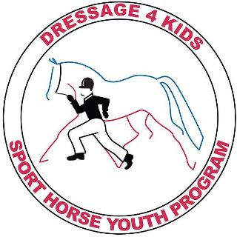
PLEASE NOTE: This session is a qualifier for Conformation and Handlers Classes at Lendon Gray’s 2013 Youth Dressage Festival scheduled for July 12-14 in Saugerties, NY. Lendon’s Youth Dressage Festival is the flagship event of Dressage4Kids, Inc. This year’s event will include a Sport Horse Handling and Judging competition. www.youthdressagefestival.com

ENTRY CHECKLIST
- Complete registration form, duplicate as needed.
- Make checks payable to: Felisberto and Orintha Silva, LLC.
- Mail to Orintha Silva, 1 Old Farm Lane, Pepperell, MA 01463.
- Bring current Coggins.
- On arrival, visit registration desk before unloading to pick up your packet and verify Coggins.

All dogs must be leashed. Call Phil Silva at 978-877-6635 or email at tenbroeckfarm@charter.net with any questions. Visit www.tenbroeckfarm.net for directions and lodging information.
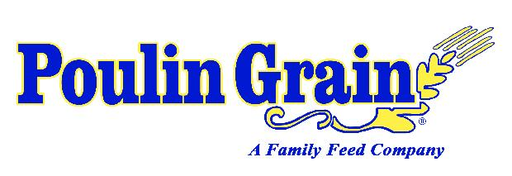
Ten Broeck Farm is fueled by

Phone: 978-877-6635 • Email: tenbroeckfarm@charter.net • 1 Old Farm Lane (formerly 49 Prescott St.) • Pepperell, MA 01463 • www.tenbroeckfarm.net

