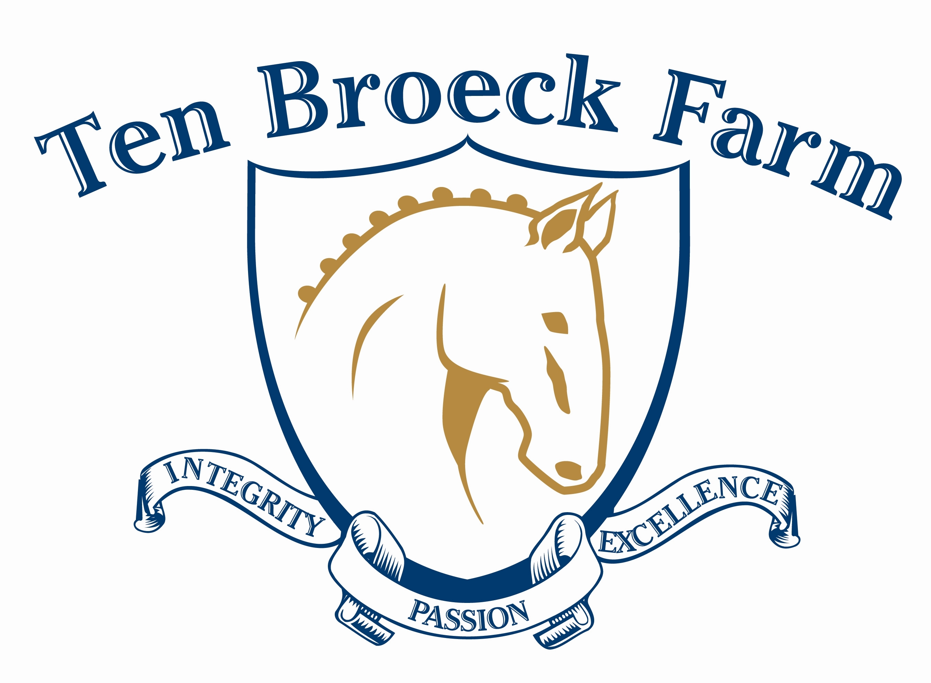
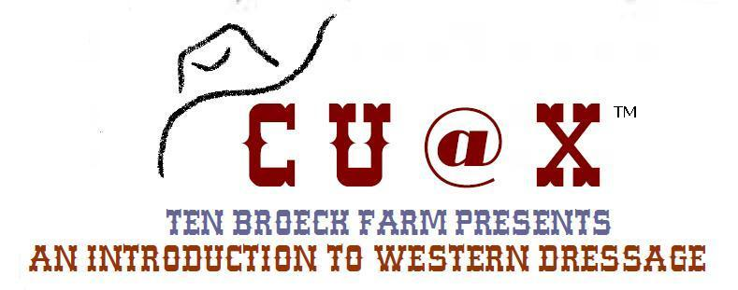

Ten Broeck Farm Presents...
In Introduction to Western Dressage
with Frances Carbonnel
Saturday, May 25 ● Sunday, May 26
~all levels welcome~
Add $10 for registrations received after May 20, 2013
WESTERN DRESSAGE CLINIC CLINICS
REGISTRATION (duplicate as needed) □ Saturday □ Sunday □ Both
NAME OF PARTICIPANT
Please consider attending both days, even as an auditor, to fully take advantage of these sessions.

ADDRESS

CITY |  |  |  |  |  | STATE |  | ZIP
PHONE/CELL |  |  |  |  |  | EMAIL
AGE | □ 4H member  □ PHOA memeber |  |  |  |  | PARENT (if under 18)
HORSE NAME |  |  |  |  |  |  |  |  |  | AGE | SEX
BREED |  |  |  | MUST HAVE CURRENT COGGINS  SEE ENTRY CHECK LIST ON PAGE 2.
EMERGENCY CONTACT |  |  | PHONE |  |  |  |  |  | CELL
SCHEDULE- PLEASE INDICATE YOUR INTEREST AREAS; WE MAY MODIFY TO MEET REQUESTS.
Day 1 |  | Day 2
- Understanding the Gaits |  | - Understanding and using the western dressage arena
- Rhythm and Tempo |  | - Understanding how to do a WD test and scoring
- Rider Position |  | - Riding a basic test-ride and receive clinician's feedback for improvement
Total number of riders:  ____________  4H and PHOA participants save $5! |  |  |  |  |  |  | Fees |  |  |  |  | Total $
 |  |  |  |  |  |  | $50.00  $45.00 per person |  |  |  |  | $
AUDITING: Non-participants/parents/spectators welcome |  |  |  |  |  |  | Phone |  |  |  |  | Total $
Name:
□ Youth □ Adult
Name:
□ Youth □ Adult
Total number of auditors: @$15.00 each |  |  |  |  |  |  |  |  |  |  |  | $
LUNCH ORDERS |  |  |  |  |  |  |  |  |  |  |  | Total $
Name:

Name:
Special concerns: |  |  |  |  | Total number of lunches: @$10.00 each |  |  |  |  |  |  | $
SATURDAY EVENING HOEDOWN – all welcome |  |  |  |  |  |  | Phone |  |  |  |  | Total $
Name:
□ Youth □ Adult
Name:
□ Youth □ Adult
Total number of guests: @$10.00 each |  |  |  |  |  |  |  |  |  |  |  | $
GRAND TOTAL $
Make checks payable to: Felisberto and Orintha Silva, LLC.

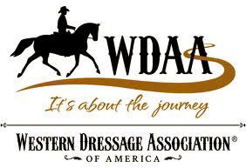

Ten Broeck Farm welcomes Frances Carbonnel as our featured clinician.
As co-creator of the Western Dressage Association of America (WDAA) we are pleased to embrace and share her teachings, as well as those
of the organization.

Frances Carbonnel- A selection of accolades
USDF Bronze, Silver and Gold Medalist, many National awards including IALHA Professional Horsewoman of the Year (twice), on the Advisory board of the Western Dressage Association of America since 2010, creator, with Neide Cooley and Cliff Swanson, of the WDAA Train The Trainers Program in 2012.

Frequently Asked Questions –excerpts as answered by the WDAA (©)

Why Western Dressage?
The Western Dressage Association® of America (WDAA) was organized to provide western riders and horses with an educational program which incorporates the principles of lightness into a whole new way of thinking about riding western. Western Dressage helps a rider to improve the horse’s balance, cadence and carriage.

Do I need special tack, equipment, or clothing to show in Western Dressage?
No! The current USEF rule book permits riders to perform the tests in either a standard western snaffle bit, which is defined in the rule book, or in a standard western bit which is also defined there. You may use your western saddle and your western headstall and reins.

What is the difference between Western Dressage and traditional Dressage?
The goals of Western Dressage and Dressage are similar. They both wish to create a better horse and rider with the use of structure and levels. The Western Dressage horse is encouraged to work and school on lighter contact than the typical dressage horses. While both want to see balance, cadence and carriage, the Western Dressage horse will be evaluated with the conformation and movement of today’s western horses in mind.

Is Western Dressage for any breed of horse?
Absolutely! Any breed of horse can participate in Western Dressage. In order to participate in the Western Dressage tests, horses should be able to walk, jog and lope, or in the case of gaited horses, walk, gait or jog and lope.

VENUE DETAILS:
Ten Broeck Farm
1 Old Farm Lane
Pepperell, MA 01463
(Mapquest/GPS using 49 Prescott Street)
www.tenbroeckfarm.net
email: tenbroeckfarm@chartner.net
ENTRY CHECKLIST
- Complete registration form, duplicate as needed.
- Make checks payable to: Felisberto and Orintha Silva, LLC.
- Mail to Orintha Silva, 1 Old Farm Lane, Pepperell, MA 01463.
- Bring current Coggins.
- Add $10 late fee for entries received after May 20, 2013.
- On arrival, visit registration desk before unloading to pick up your packet and verify Coggins.
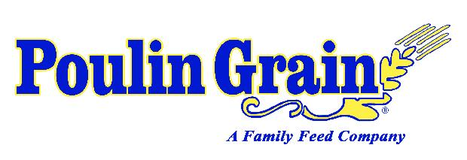
Ten Broeck Farm is fueled by
All dogs must be leashed. Call Orintha Silva at 978-877-6636 or
email at tenbroeckfarm@charter.net with any questions.
Visit www.tenbroeckfarm.net for directions and lodging information.

Phone: 978-877-6635 • Email: tenbroeckfarm@charter.net • 1 Old Farm Lane (formerly 49 Prescott St.) • Pepperell, MA 01463 • www.tenbroeckfarm.net

Massachusetts Clause
Under Massachusetts law, any equine professional is not liable for injury to, or the death of, a participant in equine activities resulting from the inherent risks of equine activities,
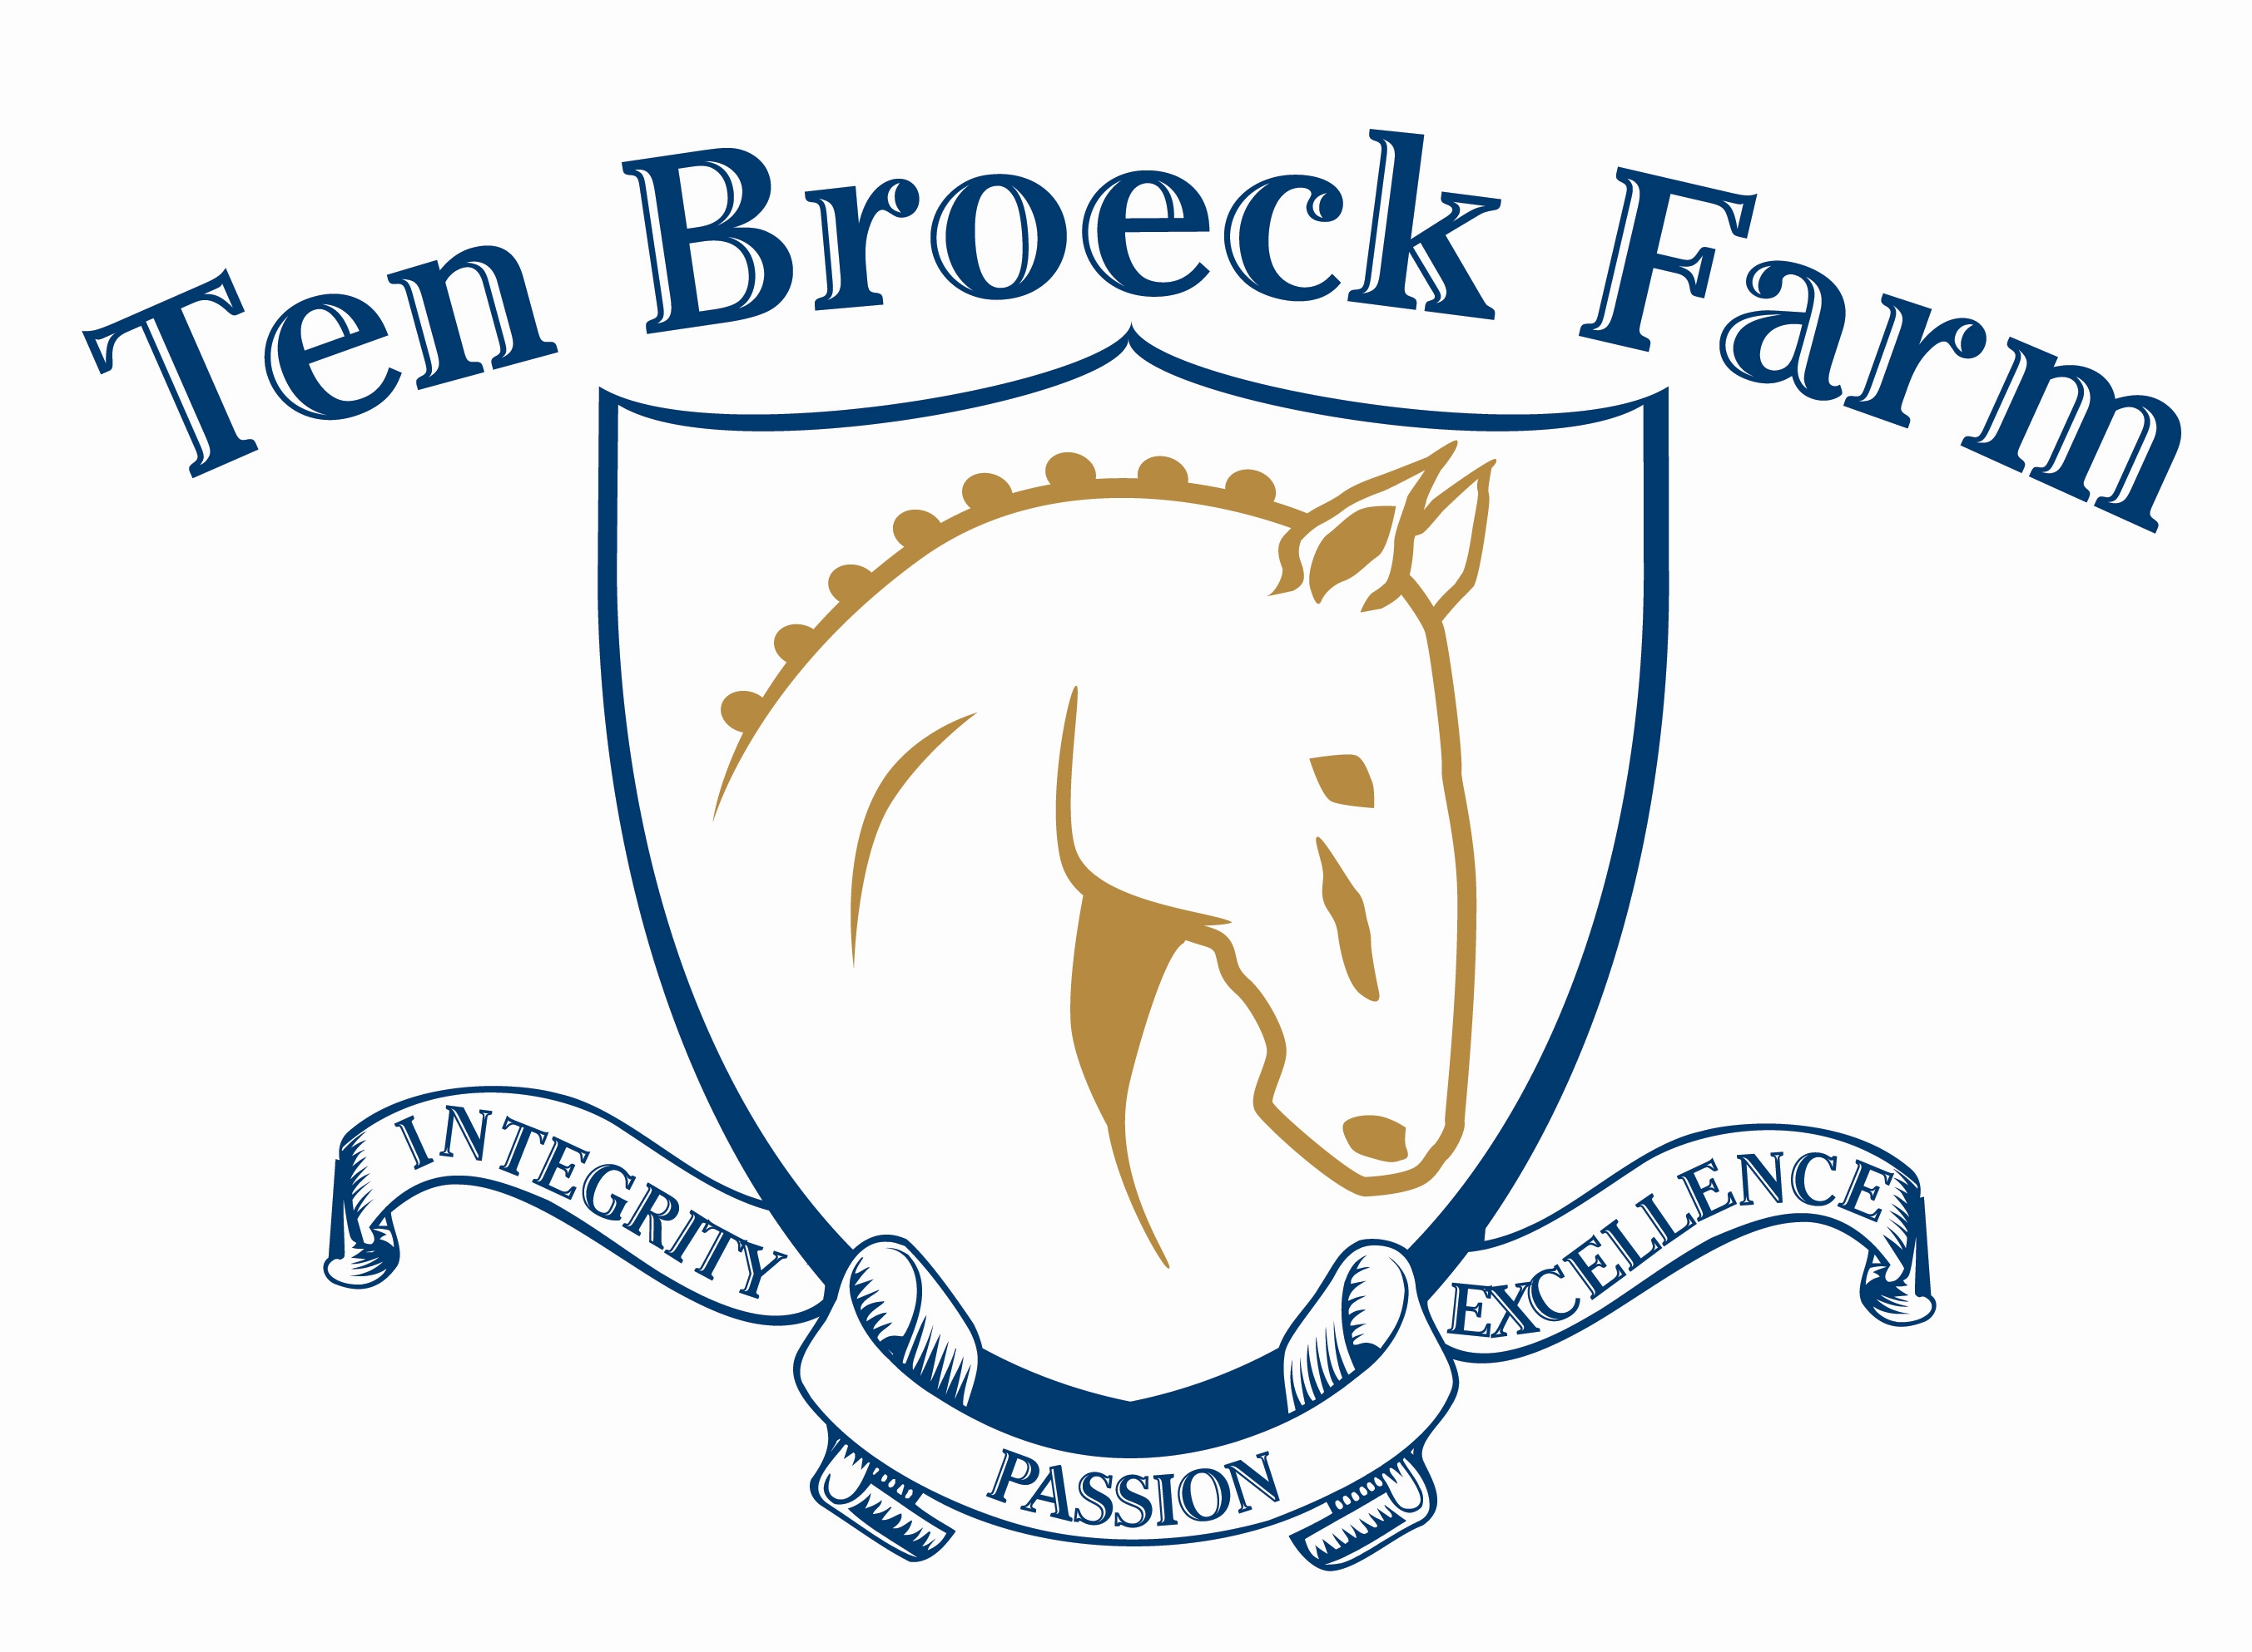
pursuant to section 2D of Chapter 128 of the General Laws.
WAIVER/RELEASE MUST BE COMPLETED, SIGNED & INCLUDED WITH ENTRY
Ten Broeck Farm Release, Assumption of Risk, Waiver and Indemnification
This document waives important legal rights. Read it carefully before signing.
I AGREE in consideration for my participation in the Competition for which this Entry Blank is used to the following:

I AGREE that I choose to participate voluntarily in the Competition with my horse as a rider, handler, longeur, lessee, owner, agent, coach, trainer, or as parent or guardian of a junior exhibitor. I am fully aware and acknowledge that horse sports and the Competition involve inherent dangerous risks of accident, loss and serious bodily injury including broken bones, head injuries, trauma, pain, suffering, or death.

With this knowledge and as an inducement for the landowners and organizers to allow me to ride on the grounds of the
Competition, I AGREE to release Ten Broeck Farm, Competition, the landowners, farms and any and all of their agents, employees, organizers, officials, directors, members, volunteers or officers (hereafter “the foregoing”) from all claims for money damages or otherwise for any Harm to me or my horse and for any Harm caused by me or my horse to others, even if the Harm resulted, directly or indirectly, from negligence of the foregoing.

I AGREE to expressly assume all risks of Harm to me or my horse, including Harm resulting from the negligence of the foregoing.

I AGREE to indemnify (that is, to pay any losses, damages, or costs incurred by) the foregoing and to hold them harmless with respect to claims for Harm to me or my horse, and for claims made by others for any Harm caused by me or my horse at the competition.

I have read Rules about protective equipment, including USEF Articles 318 and 1713, and DR120.5, as well as the NEDA Helmet Policy effective February 2011. I understand that I am required to wear an ASTM approved helmet at all times when mounted on a horse, while recognizing that no protective equipment can guard against all injuries.

If I am a parent or guardian of a junior exhibitor, I consent to the child’s participation and AGREE to all of the above provisions and AGREE to assume all of the obligations of this Release on the child's behalf.

I AGREE that Ten Broeck Farm and Competition as used above includes all of their officials, officers, directors, employees, agents,
personnel, volunteers and affiliated organizations.

BY SIGNING BELOW, I AGREE to be bound by all applicable Rules and all terms and provisions of this entry blank.
MANDATORY SIGNATURES OF PARTICIPANTS
No copies. No word “Same”. “R / H / L” indicates Rider / Handler / Longeur
Entries will not be accepted without mandatory signatures, full payment of fees, and legible proof of negative Coggins test
Any person (other than R / H / L) giving instruction, coaching, riding Horse at Event must sign below as Coach / Trainer

RIDER/HANDLER/LONGEUR (Mandatory) Signature Print Name

PARENT/GUARDIAN (Mandatory if R/H/L minor) Signature Print Name

OWNER / AGENT (Mandatory) Signature Print Name

COACH / TRAINER (If applicable) Signature Print Name

MANDATORY SIGNATURE PERTAINING TO HEAD PROTECTION
(Rider / Handler / Longeur must sign)
I AGREE TO WEAR AN ASTM APPROVED HELMET AT THIS EVENT AT ALL TIMES WHEN ON A HORSE

RIDER/HANDLER/LONGEUR (Mandatory) Signature Print Name

PARENT/GUARDIAN
(Mandatory if R/H/L minor) Signature Print Name

MEDICAL ALERT (i.e.: medication allergies)
Emergency Contact Emergency Phone Number

Ten Broeck Farm
2013 Events

Ten Broeck Farm ● 1 Old Farm Lane • Pepperell, MA • 01463

Photo Release

Photographs, videos, and/or audio clips may be taken of participants and spectators at activities held at Ten Broeck Farm. Ten Broeck Farm, and its representatives, request the right to use all photos, videos, and/or audio clips taken of youth, adults, animals, and activities. These may be used for local newspapers, promotional brochures and email marketing, promotional purpose on web sites, and to showcase equestrian programs.

By signing this form, I consent to allow Ten Broeck Farm, and its approved representatives, to use photos, videos, and/or audio clips that they have of me participating in events at Ten Broeck Farm with or without my name and for any lawful purpose, including for example such purposes as publicity and advertising. Additionally, I waive any right to royalties or other compensation arising or related to the use of these materials.

Print Name: _________________________________

Signature: __________________________________Date: _____________

Parent signature (if under 18) _____________________________ Date: __________

